Honda's Asimo  https://www.youtube.com/watch?v=QdQL11uWWcI  Answer the following question from the video: | 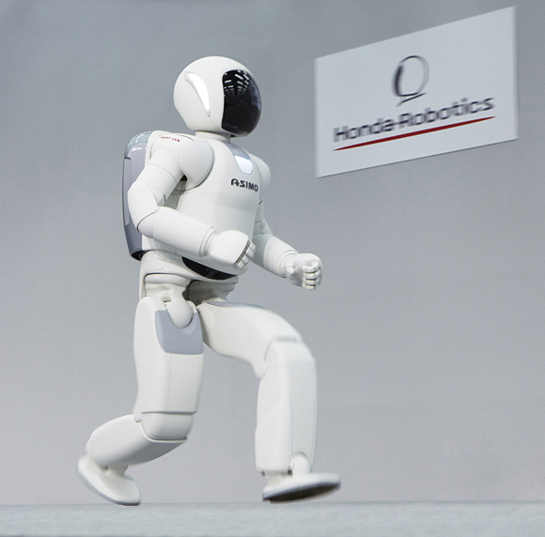
A. What can Asimo do?
1. . Movement: walk backwards, hop, walk, run, shake hand, climb stairs
2. Hobbies: Can play football, dance
2. ..Can make delicated tasks such as opening a bottle, pour the liquid in the glass
4 .Can play football, dance.
......
B. Complete the sentences about the history of Honda robotics:
1. Asimo has been designed to interact with humans.
2. This latest version of Asimo is the product of almost 3 decades of development.
3. In 1986 Honda's robot could walk very slowly and clumsily.
4. By 1996 it had become intimidatingly large.
5. In 1997 it was shrunk (encogerse) to ma less threatening size.
6. Honda unveiled Asimo in 2000

